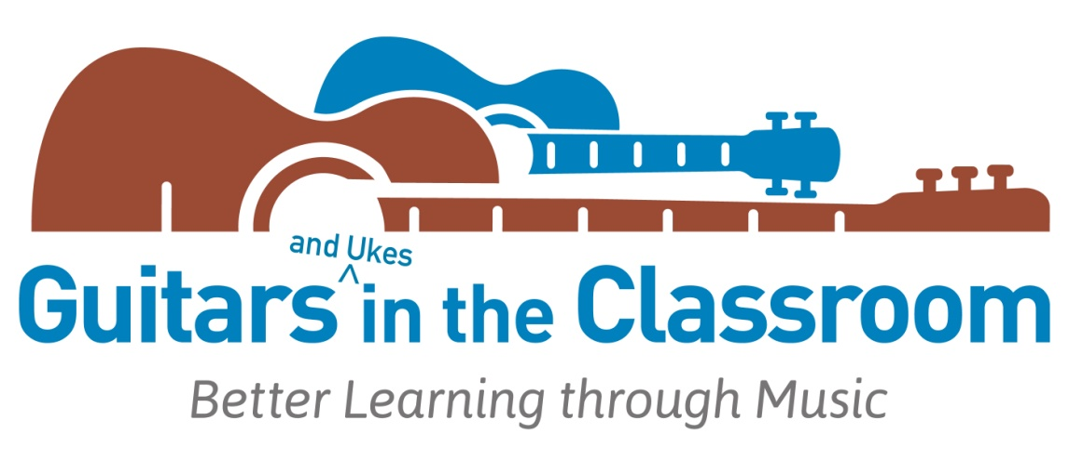
Guitars in the Classroom recognizes and celebrates

Thank you for sharing the benefits of making music with your students.


for completing and succeeding in the Songleader Plus Level course for professional development in music integration with guitars, ukuleles
and songs for learning. Thank you for your creative participation.

Congratulations!

__________________________________ _________________
Course Instructor Date

