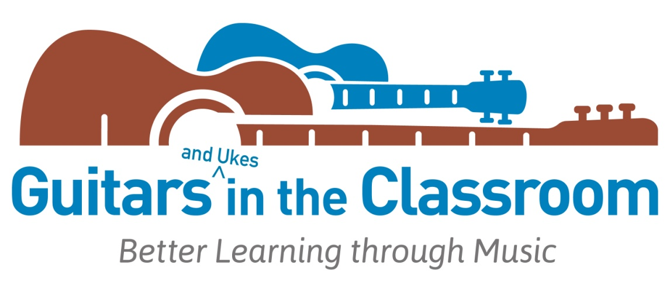
Guitars in the Classroom recognizes and celebrates

Thank you for sharing the benefits of making music with your students.


for completing and succeeding in meeting the training goals of our
Level I Professional Development Workshop for Music Educators
in music integration with ukuleles and songs for learning.
Thank you for your creative participation.

Congratulations!

__________________________________ _________________
Course Instructor Date

